4.2.8 Maximum Passenger Car Tyre and Rim Width
Tyres fitted to passenger cars or passenger car derivatives must not be more than 30% wider
than vehicle manufacturer’s widest optional tyre.
The rim width must not exceed the recommendations for the tyre fitted.
For example, if the original widest optional tyre is 185mm, the maximum tyre width is 1.3 times
185mm = 240.5mm, i.e. a 235mm wide tyre. The maximum rim width for a 235mm tyre is
9 inches if the aspect ratio is 60 or below.

Translation,
Sweet! I can fit is a 315 :D (based off 30% larger than 245)

4.2.9 Passenger Car Wheel Track
The wheel track of passenger cars (or derivatives) must not be increased by more than 25mm
beyond the maximum specified by the vehicle manufacturer for the particular model. This
means that the rim offset must not be changed by more than 12.5mm.
Reduction in wheel track must not be performed without approval of the relevant Registration
Authority.
On vehicles with diagonally split brake systems, the front wheel offset (and front wheel track)
should remain as original, except where the original manufacturer specifies differently with
optional rims for a particular model.

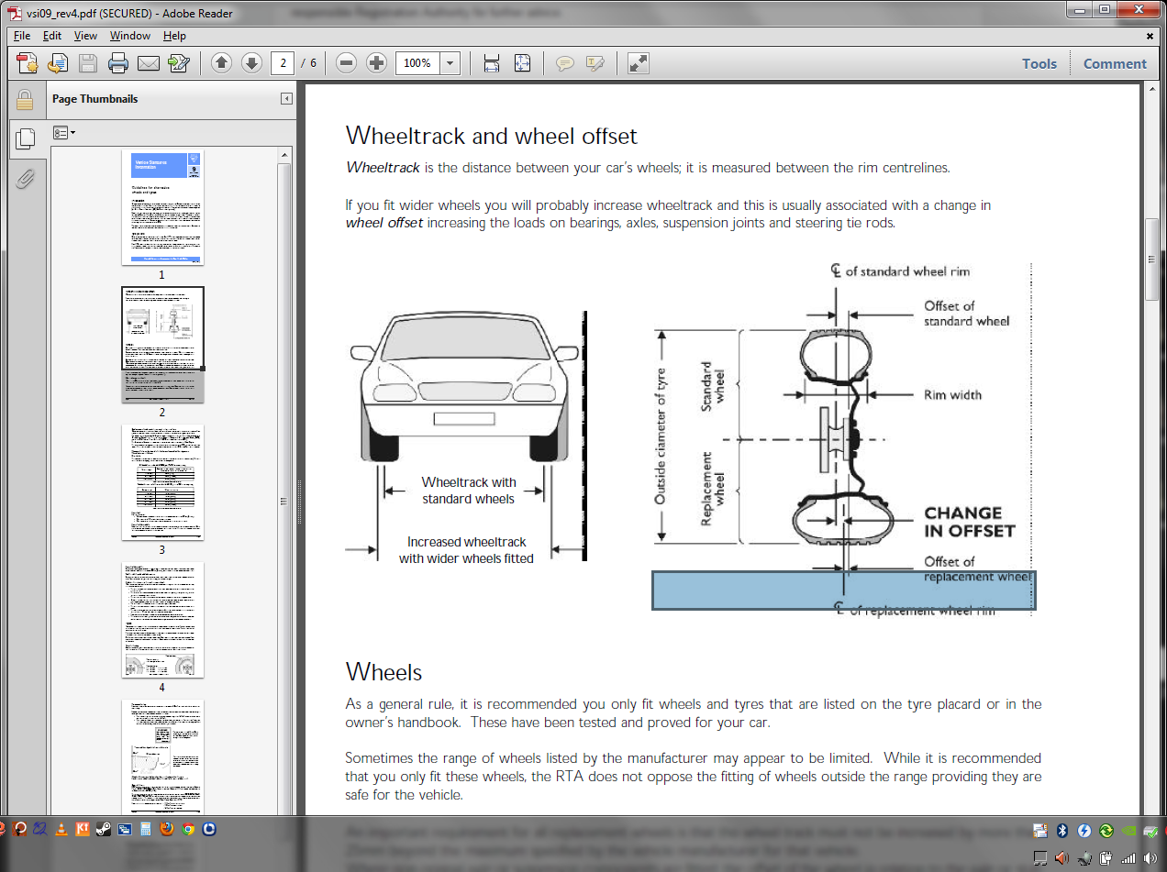

Translation,
We are a Diagonally split system, need to upgrade to bypass this....we’re screwed in that regards.
Wheel track is the CENTER LINE OF THE WHEEL so MAXIMUM legal offset is 46-12 (+34) so your 18x11 rims (to fit 315 tyres) will need to be a MAXIMUM of +34
4.2.3 Clearance
No part of the wheel must touch any part of the body, chassis, steering, braking system or
suspension under any operating condition. To check this, the vehicle must be fully laden and
capable of negotiating raised obstacles that would normally be encountered whilst driving such
as speed humps and driveway entries. This test should be conducted from lock to lock without
any part of the rim or tyre contacting any other part of the vehicle. Test weight for passengers is
68kg plus 15kg per person for luggage where luggage space is provided.

4.2.2 Wheel Attachment
Replacement wheels must be designed for the particular hub/axle and have the same bolt/stud
pitch circle diameter and the same centre location method. The wheel nuts or bolts must have
the same tapers as the wheel. Wheels with slotted bolt/stud holes must not be used.
Replacement aluminium alloy rims must be located on the hub/axle by the same diameter
centre spigot as the original wheel, using suitable adaptor rings where necessary.
Wheel nuts and bolts must have a thread engagement length at least equal to the thread
diameter, except where specified otherwise by the vehicle manufacturer.
Wheel spacers (or adaptors for dual wheel conversions) between the wheel mounting face and the road wheel must not be used unless fitted as original equipment by the vehicle
manufacturer.
Modifications to disc brake callipers, hubs and suspension and steering components to enable
the fitting of replacement wheels must not be undertaken.

4.4 SHOCK ABSORBERS
Replacement shock absorbers (including struts and strut inserts) may be used provided that
they have been manufactured as replacement units for the particular vehicle model and have
compatible mountings and dimensions.
4.5 SWAY BARS
Replacement or additional sway bars (anti-roll bars, stabiliser bars) may be fitted to front and
rear suspensions. Because additional roll stiffness at the front will increase understeer and
additional roll stiffness at the rear will increase oversteer, the incorrect choice or combination of
sway bars could lead to unpredictable handling. Additional assessment may be required, and if
necessary, expert advice should be sought.

4.7 STRUT BRACES
Transverse strut braces may be fitted between suspension strut and spring mounting towers.
Front strut braces should be kept as low as possible below the bonnet to minimise head injury
to a pedestrian from any downward impact on the bonnet.

